**Lawn Buddy AI Technology Strategy Pitch**

I**. Section One: Overview of the Strategic Problem (~1 Page)**

1. *Which company are you building an AI-powered strategy for?*

I am building an AI-powered strategy for Lawn Buddy. Lawn Buddy is a startup company operating a lawn service platform that allows lawn owners to input information about their lawn to help narrow down a list of professionals that have the required expertise, provide service to the area (including grass cutting, hedging, and trimming), and are in the price range set by the lawn owner. The LawnBuddy app also helps to take some of the guesswork out of the hands of the lawn owner by utilizing machine learning and image processing to help identify what services the lawn needs most.

*b. What are the key strategic problems this company is facing?*

* Maintaining the landscape pristine throughout the year involves a multitude of tasks that must be performed properly at the right time. A typical work order during best seasons includes around 10-14 tasks, such as condition, prepare, till, grade, fertilize, seed, mow, water, prune, and weed control. As the business is seasonal, you cannot risk delays, as it would mean losing the advantage of natural processes. In addition, scheduling and dispatching landscapers on time with the right equipment make a big difference to operations and profitability.
* Since the business is seasonal, keeping the equipment safe and in a ready-to-operate condition when the crew needs them at the job site is a challenge and requires proper usage and maintenance on a routine basis.
* Green industry regulations at state and municipality levels whether it is related to the use of pesticides and fertilizers or the equipment and pollution levels is a big challenge for Lawn Buddy. Although regulations are there to protect public health and security and conserve property, their cost impact on the business is mostly high.

*c. What is your solution(s) to these strategic problems?*

* Lawn Buddy should use AI’s object recognition to scan and evaluate the lawn to determine the right time to perform lawn maintenance tasks. In addition, Lawn Buddy should also utilize a user-friendly lawn service scheduling feature where it lists all available landscapers and equipment for a certain schedule.
* Lawn Buddy should use either a landscaping management software, CMMS, or an equipment maintenance program to record, track, and monitor the equipment, and set a configurable preventive maintenance schedule to notify the crew member about the upcoming maintenance. Having visibility into the inventory and historical usage data can track the equipment in use in real-time and bring predictability to the maintenance and service plans of equipment based on those historical usage data.
* Lawn Buddy needs to get more involved in the state-level associations to stay on top of the regulations. This could help us to engage in substantial lobbying activities to influence the decisions on pressing issues. In addition, on operations levels, Lawn Buddy should rely more on technology to keep its employees abreast of the latest regulations and guidelines. Having the right inspection tools, historical records, and a knowledge-base integrated with the internal systems like field service platform that are accessible by the employees anytime, anywhere could help in keeping up with the regulatory standards. Lastly, the company can conduct post-work inspections that ask the workers to perform checklist-based inspections to ensure they have followed the guidelines and validated with the right proofs like images and videos help in compliance.

**II. Section Two: Customer Segmentation Strategy (~1 Page)**

1. *What is the major adopter segment on the TALC that you are targeting?*

Lawn Buddy is targeting early adopters as they are happy to test the product, provide feedback, implement innovativeness, and hope to simplify everyday tasks. Moreover, they can promote the product in their social circles and improve the reputation of the brand. Lawn Buddy will maintain their interest and engagement by keeping them informed and giving early access to new features.

The targeted early adopters will be those who are busier than others and do not have time to dedicate to lawn maintenance as well as those that are physically unable to provide care to their lawn like the elderly, sick individuals or disabled persons in addition to those who do not have lawn care tools and seek lawn services.

1. *What are the functional, emotional, and social objectives that your target customers have in evaluating the tools they use to complete their core “jobs?”*

* Functional: Target customers need to have mobile devices with minimum specification requirement (camera, sensors, and AR) and basic technical skills to be able to complete the lawn maintenance process in a user-friendly/easy-to-understand (important aspect for elderly customers) and fast way (important aspect for young professionals who are usually busy and don’t have a lot of free time). In addition, customers need to go through the whole app process of lawn maintenance starting from app authentication to taking a picture of the lawn for grass length detection to scheduling available lawn professional till the checkout and appointment confirmation stage to be able to evaluate the whole app experience.
* Emotional: Target customers (especially elderly people) need to feel relaxed once they complete the app’s lawn maintenance process especially if they find lawn mowing as a relaxing hobby. For busy customers and young professionals, they need to feel content that they spent less time using the Lawn Buddy app than if they maintained their lawn themselves.
* Social: For customers who are environmentalists and active in various communities, they need to feel pride that they reduced carbon emissions, built soil organic matter, and even enhanced pollinating habitats for bees by mowing their lawn using an app that their fellow environmentalists use. Similarly, customers who are tech enthusiasts or member of technology associations that have an affinity for high-tech mowing tools and regularly discuss new products they’ve tried, should also feel content and proud that they used a lawn mowing app that utilizes high-tech features like AI in lawn mowing which led them to bond more with other association members.

**Section Three: Outline AI/Data Strategy (~2 Pages)**

1. *What is your data pipeline? What kinds of data are you collecting?*

* Lawn Buddy has a thorough dataset of all types of lawns to have the most accurate reading of the image recognition like lawn color/quality, blade length, lawn size, and lawn terrain. Analyzing the pixels in the image recognition would allow our users to submit photos of their lawns and receive recommendations for service based on a model that we have built. To do this, there are several steps that need to be followed. First, we would conduct data acquisition. This would entail gathering large quantities of relevant images of lawns. Second, we would process the data. In our case, this would involve segregating the data out into multiple steps of sample data required for the training of the system since we are planning to use supervised learning. We would further process this using an action upon discrete data approach to best provide a working model to our users. Third, we would model the data based on a specific algorithm tailored to our needs. Fourth, we would experiment with the algorithm and model to tune the system to make decisions in an acceptable manner. Fifth, we would deploy the completed system.

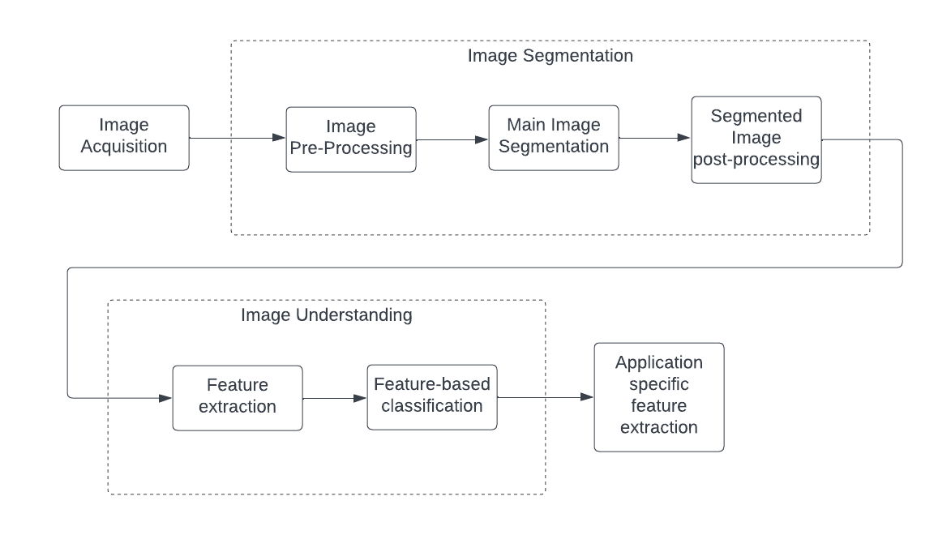

Figure 1 The process from data acquisition to model completion

* Lawn Buddy uses Auth0 React SDK to identify its users, get their profile information, and control the content that they can access by protecting routes and API resources like account or checkout pages. We first integrate Lawn Buddy with Auth0 so that it can redirect users to an Auth0 customizable login page when they need to log in. Once users log in successfully, Auth0 redirects them back to the app, returning JSON Web Tokens (JWTs) with their authentication and user information.
* Lawn Buddy uses a combination of React.JS to display the schedule, controller to manipulate the schedules, and MongoDB database to store the schedule information for both types of users i.e., customers and lawn service professionals, leading to a better organized code base for the app that can be easily modified and maintained, and faster development process because of how MVC allows parallel development on both design and functionality.

Figure 2 High-level view of MVC

*d. What are your key AI-algorithms?*

* Lawn Buddy uses the cutting edge technology of object recognition, a principle of machine learning and deep learning where computer vision technique allows users to identify and locate objects in an image. By analyzing the pixels in the image recognition, Lawn Buddy can interpret and understand the logistical nature of lawn care services needed.

Figure 3 How Object Recognition Works (https://blog.superannotate.com/object-detection-with-deep-learning/)

* By analyzing the dataset, Lawn Buddy uses the criteria of computer vision in order to break down the classification, localization and tagging. Lawn buddy uses the classification feature to detect the lawn, and the use of localization to determine lawn size, and the tagging feature to further find the lawn quality, which is measured through lawn color, and blade length which determines when the lawn needs to be trimmed.
  + Lawn quality: measured by the appearance and color of the lawn e.g., yellow lawn = poor quality
  + Blade length: measured by analyzing the individual blade e.g., blade > 3 inches = long, time for maintenance
  + Lawn size: measured by the phone's AR feature e.g., 20 x 15 sq. ft.
  + Lawn terrain: measured by the topography of the yard e.g., hills = non-flat terrain

Figure 4 How Object Recognition Works in Lawn Buddy

**III. Section Four: Overview of Value Network & Ecosystem Strategy (~2 Pages)**

*a. Describe your value network. Who are the key players? What will they contribute to the value creation process?*

Figure Lawn Buddy app's value network

*b. Summarize your overall technology strategy. Make sure you pull from the initial readings on technology strategy (Hint: 3 major dimensions of a good technology strategy are listed in all of the case rubrics)*

*i. Specify your technology strategies*

*ii. Identify the source of competitive advantage*

*iii. Describe how your proposed strategy solves the problem you have identified*